# Chrome_TC_02:Sales_Order_Creation

### Orient LED Login Page.

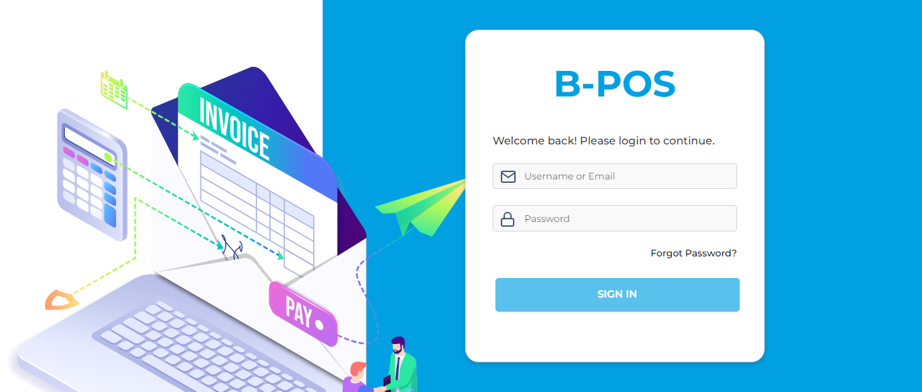

### The Home page with lot of navigation options to navigate different modules and serving as the entry point to the website.

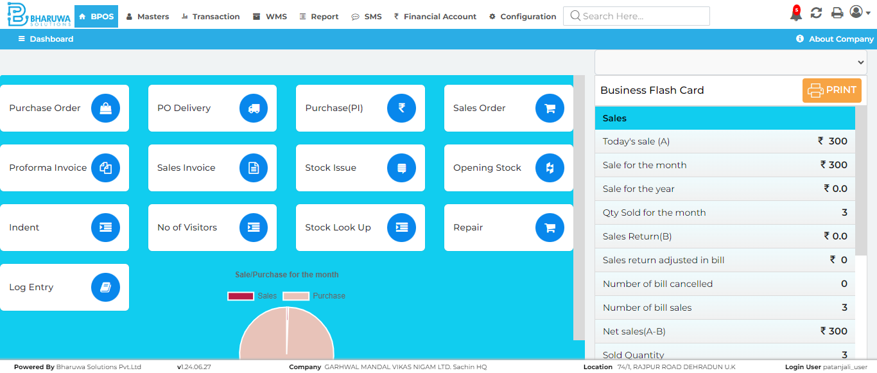

### Transaction module with lot of sub-modules to perform vairous transactinos for user.

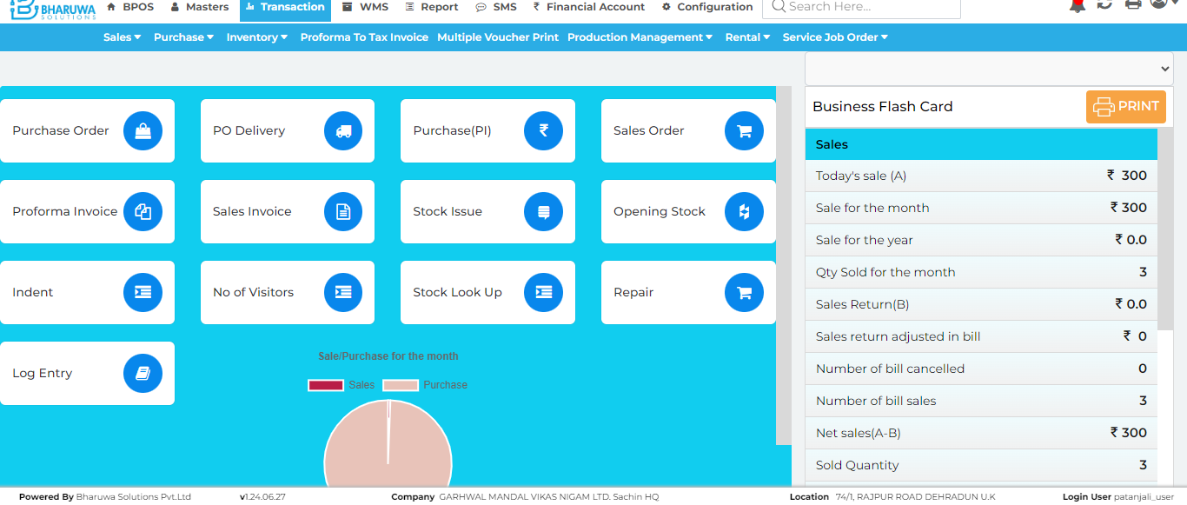

### Sales order screen, where user can create sales order for preferred customer.

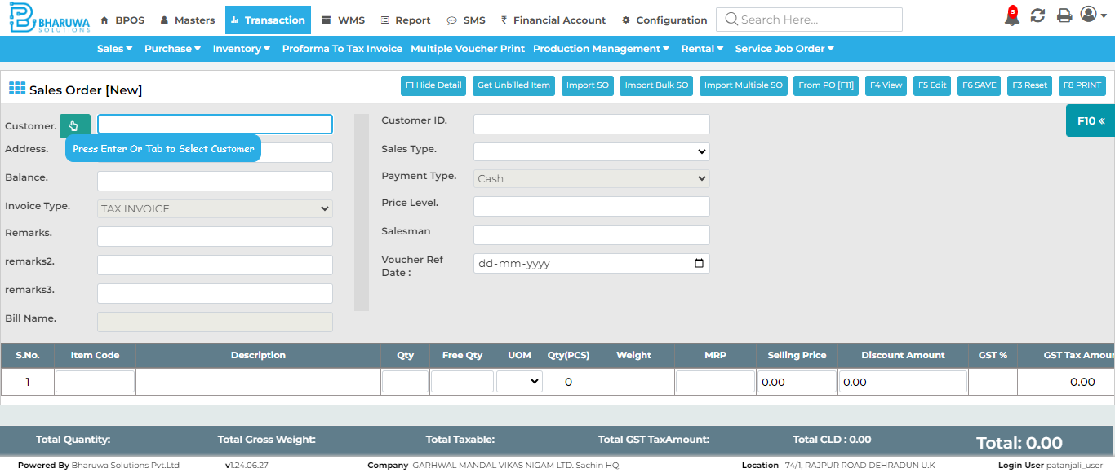

### Successfully created sales order with preferred customer and items.

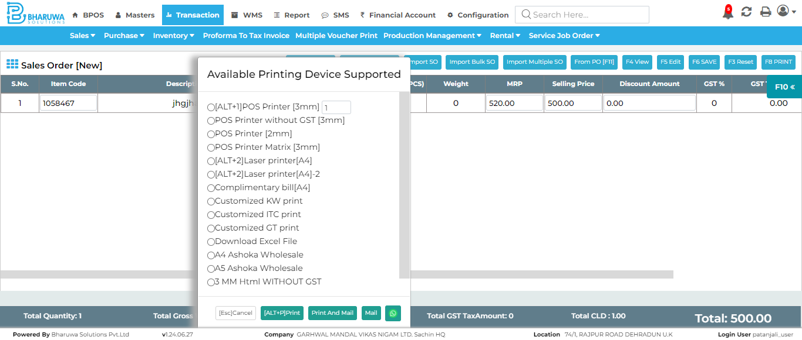

#### TC_02 - TEST PASSED